SACRED HEART UNIVERSITY

GRADUATE PROGRAM IN OCCUPATIONAL THERAPY

OT525
Health & Wellness: Personal Journey

COURSE SYLLABUS
FALL 2018

Credit Hours: 0.5
Course Instructors: Sheelagh Schlegel
Office Phone: 203 365 4773
Office E-mail: schlegels@sacredheart.edu
Office Hours: By appointment
Class Times: Wednesdays 1 – 2pm (Alternate Group A and Group B, each group every other week except October 3rd)

COURSE DESCRIPTION

This course consists of the personal pursuit of one’s well-being: mind, body and spirit. Students will reflect on different dimensions of wellness, health literacy and the biological and environmental (physical and social) forces, both controllable and uncontrollable, that affect health and well-being.

RELATIONSHIP TO CURRICULUM DESIGN

Our curriculum design is portrayed in the symbol of the tree of life. This tree reflects our beliefs about the complexity and dynamic nature of human learning. In this tree, the roots consist of the foundational knowledge students need to become an exemplary practitioner; the trunk symbolizes the process that supports the scaffolding of knowledge and critical thinking; and the branching of the tree and leaves symbolizes the skills, abilities, and professional behaviors of the entry level clinician graduating from our program. This process is not a hierarchical but a heterarchical one whereby learning occurs not in linear isolation but in a dynamic environment which constantly creates a stream of knowledge to nurture the unique development and emergence of the professional. The tree’s branches circle back to its roots, demonstrating the continual process of learning and the integration of new information with the foundational roots as an occupational therapist grows throughout a lifetime of practice. The entire tree is set within a nutrient rich environment, the faculty and the university, that supports its growth. As one of the early courses in our curriculum, this course is designed to plant you firmly in the foundational roots of the profession of occupational therapy. You will apply the knowledge you learn in this course to your labs, fieldwork, and problem based learning (PBL) cases for the next few semesters as you develop and implement activities for real and imagined clients. You will also apply this knowledge as you work together and teach each other in PBL.

RELATIONSHIP TO OCCUPATIONAL THERAPY PRACTICE AND THE CENTENNIAL VISION
“a powerful, widely recognized, science-driven, and evidence-based profession with a globally connected and diverse workforce meeting society’s occupational needs.”
(or….. why you need to know this)

CONCEPTUAL MODEL FOR THIS COURSE
The conceptual model I have chosen for this course is Bandura’s Social Learning Theory, the Personal Environmental Occupation Model, the Health Belief Model and The Transtheoretical Model for Behavior Change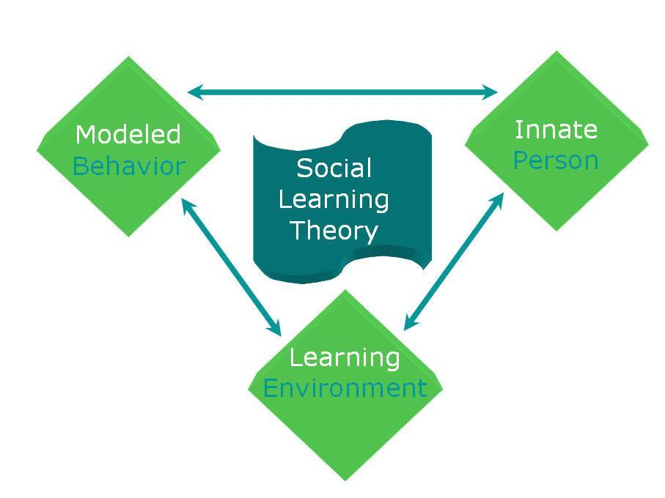
Person, Environment, and Occupation Model (PEO) (Law, Cooper, Strong, Stewart, Rigby, & Letts, 1996)

Reproduced for this syllabus and educational purposes only from: Law, M., Cooper, B., Strong, S., Stewart, D., Rigby, P., & Letts, L. (1996). The person-environment-occupation model: A transactive approach to occupational performance. Canadian Journal of Occupational Therapy, 63,(1), 9-23.

OUR THOUGHTS ABOUT LEARNING
(and how they will impact you in this course)

Acquiring knowledge is a dynamic process that is layered and supported by a solid foundation of knowledge, development of psychomotor and procedural skills, process, thinking, and reasoning skills, and reflection and analysis of one’s biases and values, to make sound ethical and clinical judgments based on one’s own and AOTA’s core values and ethics. Building the skills to make sound, humane, and evidence based ethical and clinical decisions takes patience, persistence, active engagement, as well as a willingness to accept that proficiency takes time and hard work. I believe that students learn best in a safe but challenging environment and a student’s ability to learn is dependent on perceived self-efficacy to succeed and an environment that is conducive to success. It is my commitment to each student to provide a positive safe learning environment, inclusive of multiple opportunities to reflect, grow, challenge, and practice, coupled with my personal belief that all students will accomplish the objectives of this course.

TEACHING LEARNING METHODS
This course will be taught using a variety of methods and strategies. In class lectures, seminars, in class and activities, will all be used to integrate and apply information to occupational therapy practice.

LEARNING OBJECTIVES
(what will you know and be able to do when you are done with this class?)

You will be able reflect on the different dimensions of wellness, understand occupational balance and develop skills to maintain or improve your personal wellness while a student in the graduate occupational therapy program.

WHAT I EXPECT FROM YOU
- Regular attendance is required. All material covered in class is your responsibility even if you are absent.
- Assignments must be turned in on time and follow appropriate APA formatting.
  - Late assignments must be communicated in advance to the instructor in order for them to be accepted.
  - Late assignments communicated to the instructor will be accepted but will result in grade reduction. Each day the assignment is late will result in the reduction of the final grade by one portion of a letter grade.
  - Late assignments without communication with the course instructor(s) will not be accepted and will be given a grade of 0.
  - Assignments turned in that are not completed in APA formatting, or, where the student has not applied previously corrected formatting errors; will be returned to the student un-read and un-graded. The grade for the paper will automatically be reduced by one half a grade. Students are expected to re-write and re-submit papers within two days of the date the paper was returned or the date specified by the course instructor. Papers turned after that deadline will be subject to additional grade reductions as outlined in the late assignment policy.
  - Assignments with excessive grammatical or spelling errors within the first paragraph will be returned to the student and the grade for the paper will automatically be reduced by one-half a grade. Students are expected to re-write and re-submit papers within two days of the date the paper was returned or the date specified by the course instructor. Papers turned after that deadline will be subject to additional grade reductions as outlined in the late assignment policy.
- Students are expected to have completed assigned readings prior to the class to which they are assigned.
- The instructor expects honesty and integrity from all students regarding their submitted work. Any work submitted as one’s own, without appropriate quoting and citing, or with apparent plagiarism, will be cause for recommendation to the Dean for academic probation or dismissal. A second infraction may be cause for recommendation for dismissal from the program. Refer to the Sacred Heart University Bulletin for the University’s academic integrity policy and standards. Students may choose to submit drafts of assignments through Safe Assign to ensure that their work is correctly cited before submitting it to the instructor.
- Students must complete their own work unless the assignment calls for group collaboration and the handing in of one group paper.

GRADING
You will have in class and other assignments which are all due on Bb. Participation in activities is crucial for your understanding of this content, so there is a participation portion of your grade.

Health risk assessment reflection…………………………………………………20%
Spiritual Assessment/Occupational Bridge assignment……..………………... 30%
Wheel of Life reflection (in class assignment)………………………………….. 30%
Attendance..…..………………………………………………………………….. 10%
Facebook participation/survey……………………………………………………10%

There will be rubrics for all assignments on BB.
DESCRIPTION OF ASSIGNMENTS
The overriding criteria are originality and authenticity. If the writing is identified as not being original, and/or not done by the student, the instructor has the right to grade the paper as an F and procedures as outlined in the policies and procedures manual for plagiarism will be followed. All assignments, however short, must be in APA format
Assignment | Description
Health risk assessment reflection – in class | Type a 1-page reflection on your health risk assessment – instructions on BB  The assessment can be found at: https://wellness.uwsp.edu/other/lifescan/lifescan.asp
Occupational Bridge plan and goals | Using your spiritual assessment completed in pairs, provide a summary of the assessment and complete an occupational bridge plan with a maximum of 3 goals – instructions on BB
Wheel of Life Assignment – in class | Complete the wheel of life on the following website:  http://www.mindtools.com/pages/article/newHTE_93.htm  and then write a 2 paragraph reflection of the experience and submit on Bb – see instructions on Bb
Facebook Page participation | Please join the course Facebook Page by “liking” it. Please read content on the page throughout the semester and participate in the post-course survey on the use of social networking to facilitate student wellness.

PULLING IT ALL TOGETHER
Each program in OT must meet the same Accreditation Council for Occupational Therapy Education (ACOTE) standards. How they are met varies from program to program. In each program, each standard must be addressed in at least two courses. The standards that are addressed in this course are listed below. To review each standard, please refer the AOTA website at http://www.aota.org/nonmembers/area13/links/LINK13.asp.

Our learning objectives are linked to the standards as well as our program objectives, our program mission and vision, and our overall curricular design. The SHU OT program has written program objectives to be met by the time you have graduated that were developed based upon our PRIDE vision.

So, to pull this all together for you, here are the course learning objectives, the program objectives they are linked to, the ACOTE standards that are addressed in this course, as well as how I plan to meet and measure the learning objectives for this course.

Learning Objective | Program Objective | ACOTE standard | Learning Experiences | How will the Learning Objective be Measured?
Students will evaluate their own levels of wellness | Demonstrate self-reflection  Exhibit critical thinking, clinical reasoning, and competence in skills requisite for entry-level occupational therapy practice | B.2.4: Articulate the importance of balancing areas of occupation with the achievement of health and wellness. | Lecture | Health risk assessment  Wheel of Life  Assignment
Students will demonstrate identification of and understanding of the personal characteristics and interpersonal traits they have and those they wish to develop. | Deepen the ability to self-reflect on experiences to drive one’s personal growth, professional development, practice, and scholarship. | B.5.7; Demonstrate therapeutic use of self, including one’s personality, insights, perceptions, and judgments, as part of the therapeutic process in both individual and group interaction | Seminar discussion, readings, online and textbook surveys, written reflection, goal setting
Students will reflect on their own spiritual growth and development for creating a context for healing, resilience, and meaningful occupation. | Deepen the ability to self-reflect on experiences to drive one’s personal growth, professional development, practice, and scholarship. | B.5.7: Demonstrate therapeutic use of self, including one’s personality, insights, perceptions, and judgments, as part of the therapeutic process in both individual and group interaction | Assigned readings  Lecture | Occupational Bridge Assignment
Apply concepts of occupational balance to your own life. | Exhibit critical thinking and clinical reasoning skills requisite for entry-level occupational therapy practice and ongoing continued competency. | B.2.4: Articulate the importance of balancing areas of occupation with the achievement of health and wellness.  B.1.8 Articulate the influence of social conditions and the ethical context in which humans choose and engage in occupations. | Assigned readings  Lecture | Time Use Assignment  Wheel of Life  Assignment

RECOMMENDED TEXTS

Scaffa, M, Reitz S. & Pizzi, M. (2010) Occupational Therapy in the Promotion of Health and Wellness. Philadelphia: F.A. Davis Company.

Rosenfeld, M. (1993). Wellness and Lifestyle Renewal. Bethesda: American Occupational Therapy Association.

Insel, P & Roth, W. (2012). Connect Core Concepts in Health, 12th edition. New York: McGraw-Hill Companies, Inc.

RESOURCES AVAILABLE TO YOU
In addition to me, you have the recommended textbooks which should help you to answer many of the questions you will need to answer in this course. If you find a concept difficult to understand, there are a multitude of additional textbooks available to you in the Cambridge Library, the Ryan Matura Library, and in our faculty library as well.

TOPICAL OUTLINE
Class Session and Date | Topic | Readings | Assignments
Week 1  Aug 29th (Group A) or Sept 5th (Group B)  ONLINE LECTURE | Introduction to Wellness  The six dimensions of wellness  Health Risk Assessments | Please read the syllabus | Start health risk assessment
Week 2  Sept 12th (Group A)  or 19th (Group B) | Modes and Traits | Taylor, R. Becoming a Better Therapist: Self-Care and Developing Your Therapeutic Use of Self . Ch 16 | Health risk assessment summary due 9/15
Week 3  October 3rd  All students | Emotional Wellness  “Stress – Portrait of a Killer” National Geographic Documentary | Readings on BB | Stress test – class activity
Week 4  Oct 17th (Group A)  October 24th (Group B) | Physical Wellness | Readings on BB
Week 5  Oct 31st  Group A  November 7th  Group B | Spirituality and Occupational Therapy | McColl (2003) Spirituality in Occupational Therapy Chapters 6,7,9 – on BB | Spiritual Self Assessment – done in class
Week 6  Nov 14th  Group A  Nov 28th  Group B  (November 21st – no class, TG Holidy) | Spiritual Wellness – guest speaker | Readings on BB | Occupational Bridge due November 17th
Week 7  December 5th  Whole class together | Occupational Balance  Health and Wellness  Health Literacy | Readings on BB | Wheel of life assignment to be done in class  Wheel of Life reflection due by December 9th
Week 8  Finals week  Week of Dec 10th | No class – practice what you have learned!! |  | Post Twitter survey- participation grade

